**LAB 3**

**Provisioning an EC2 instances on AWS**

**STEP 1: Create a new Directory.**



**STEP 2: Create terraform configuration file (main.tf)**

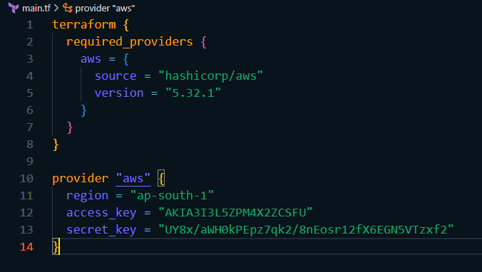

**STEP 3: Initialize terraform using ‘terraform init’ command.**

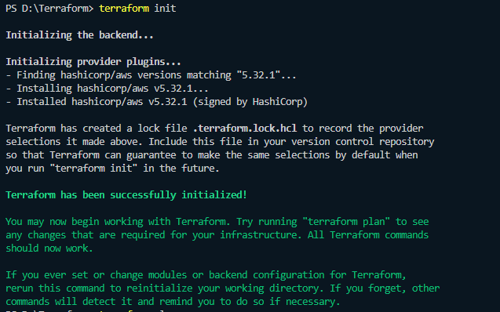

**STEP 4: Create Terraform Configuration file for EC2 instance (instance.tf)**

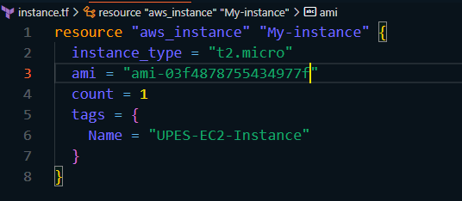

**STEP 5: Review Plan.**

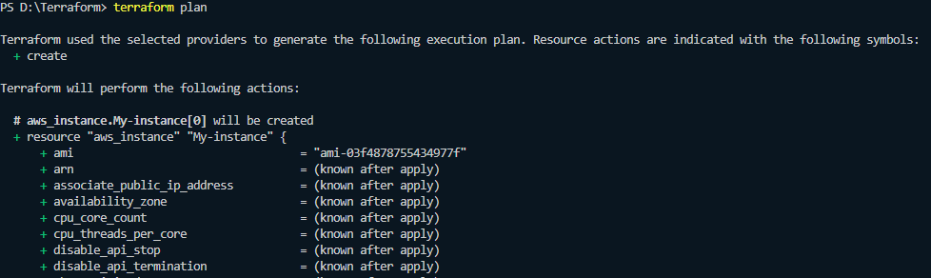



**STEP 6: Apply changes.**

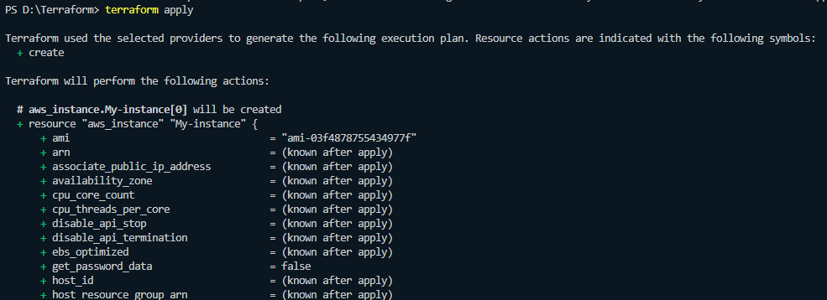

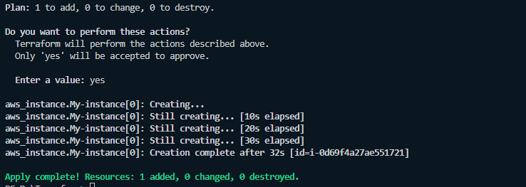

**STEP 7: Verify resources.**

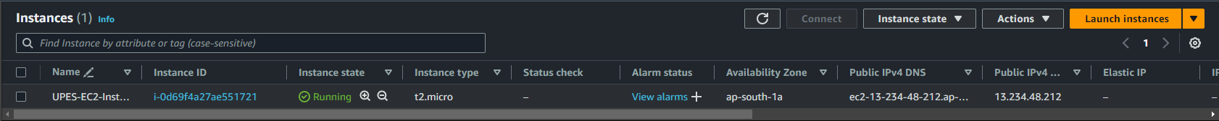

**STEP 8: Cleanup Resources.**

